

**GITAM School of Business**

**Visakhapatnam**

**MBA (2024-26)**

Title of the Project

**A Purchase Behaviour Analysis with Product Reviews and Ratings on Amazon Customers**

as a part of the fulfilment of the Course

**24OPSC6021 - Business Research Methodology**

***Term-IV, March - May, 2025***

***Submitted by***

Team 1:

1. Mohan Kumar Kosanam- 2024032474

2. Namballa Roopesh- 2024000849

3. Vindhya Patchava- 2024018933

4. Mungi Mounika- 2024003554

5. Chandra Sekhar Pasi- 2024010593

***Submitted to***

Dr. Subrahmanyam A

Course Instructor, BRM

**Table of Contents**

Chapter 1: Introduction 9

1.1 Background of the Study 10

1.2 Problem Statement 10

1.3 Need and Importance of the Study 10

1.4 Scope of the Study 10

1.5 Organization of the Report 11

Chapter 2: Review of Literature 12

2.1 Key concepts/theories/models 12

2.2 Summary of a few relevant past studies 12

2.3 Research Questions 14

2.4 Research Objectives 14

2.5 Hypotheses 15

Chapter 3: Research Methodology 16

3.1 Research Design 16

3.2 Sampling Design 16

3.3 Data Collection Method 16

3.4 Questionnaire Design 16

3.5 Data Analysis Tools 16

Chapter 4: Data Analysis and Interpretation 17

4.1 Descriptive Analysis 17

4.2 Inferential Analysis 21

Chapter 5: Findings, Discussion, and Implications 34

5.1 Discussion on Major Findings 34

5.2 Practical Implications 35

Chapter 6: Conclusion and Recommendations 36

6.1 Summary of the study 36

6.3 Limitations of the study 36

6.4 Suggestions for future research 36

References 37

Annexures 40

**List of Tables**

**Table 1: Descriptive Statistics** 15

**Table 2: Hypothesis 1- Age Group Frequency** 17

**Table 3: Hypothesis 1- Purchased Category Frequency** 18

**Table 4: Hypothesis 1- Gender Frequency** 19

**Table 5: Hypothesis 1- Reliability Test** 19

**Table 6: Hypothesis 1- KMO and Bartlett's Test** 19

**Table 7: Hypothesis 1- ANOVA** 20

**Table 8: Hypothesis 2- Correlation between @6, @17, @19 and @20** 20

**Table 9: Hypothesis 2- Regression** 21

**Table 10: Hypothesis 2- ANOVA** 21

**Table 11: Hypothesis 2- Mann-Whitney Test** 22

**Table 12: Hypothesis 2- Chi-Square Test** 22

**Table 13: Hypothesis 3- Paired Sample Correlation** 23

**Table 14: Hypothesis 3- Paired T-Test** 23

**Table 15: Hypothesis 3- ANOVA** 23

**Table 16: Hypothesis 3- Multiple Regression** 24

**Table 17: Hypothesis 4- Correlation with @6** 24

**Table 18: Hypothesis 4- Correlation with @12** 24

**Table 19: Hypothesis 4- Correlation with @13** 25

**Table 20: Hypothesis 4- Correlation with @14** 25

**Table 21: Hypothesis 4- Correlation with @15** 25

**Table 22: Hypothesis 4- Correlation with @17** 25

**Table 23: Hypothesis 4- Correlation with @19** 26

**Table 24: Hypothesis 4- Correlation with @20** 26

**Table 25: Hypothesis 4- Regression** 26

**Table 26: Hypothesis 4- ANOVA** 27

**List of Figures**

**Figure 1: Frequency @Age group** 17

**Figure 2: Frequency @Gender** 17

**Figure 3: Frequency @Occupation** 17

**Figure 4: Frequency @Amazon shopping Frequency** 18

**Figure 5: Frequency @Average amazon purchases** 18

**Figure 6: Hypothesis 4- Histogram for @6** 31

**Figure 7: Hypothesis 4- P-P Plot of Regression for @6** 31

**Declaration**

We hereby declare that the project titled **“**A Purchase Behaviour Analysis with Product Reviews and Ratings on Amazon Customers**”**  submitted to GITAM School of Business, is a bonafide record of original work carried out by us as a part of the course 24OPSC6021 Business Research Methods during the Term-4, MBA (2024-26).

We confirm that:

* This project is the result of our own efforts and has not been submitted, either wholly or partially, for any other course or program.
* All data collected, analyses conducted, and interpretations made are based on our understanding and application of the research methods taught in the course.
* All sources of information have been duly acknowledged.

We understand that any false claims or academic dishonesty may result in disciplinary action as per the institution’s rules.

**Submitted by:**

|  |  |  |
| --- | --- | --- |
| **S.No** | **Roll Number** | **Name** |
| 1 | 2024032474 | Mohan Kumar Kosanam |
| 2 | 2024000849 | Namballa Roopesh |
| 3 | 2024018933 | Vindhya Patchava |
| 4 | 2024003554 | Mungi Mounika |
| 5 | 2024010593 | Chandra Sekhar Pasi |

**Place:** Visakhapatnam  
**Date:** 9 May 2025

**Acknowledgement**

We would like to give our warmest thanks to our course instructor, Dr. Subrahmanyam A., who has provided us with abundant guidance and advice to make this work possible. We would also like to thank our families and friends for giving us continuous support, necessary comments, and suggestions regarding our paper. Furthermore, we would like to give our utmost gratitude to all the respondents who took out their valuable time to fill our questionnaire which made this paper possible. Finally, we would like to thank God, for guiding us through all the difficulties.

# Chapter 1: Introduction

## 1.1 Background of the Study

As the largest e-commerce platform, analysing Amazon product ratings and reviews, which influence customer choices ever so frequently, helps one understand dynamic consumer behaviour (Rathva & Rajput, 2024). Studies indicate that 95% of consumers read online reviews before making a purchase, and 72% of shoppers trust online reviews as much as personal recommendations (Consumer Behavior Report, 2021). However, despite their prevalence, the extent to which these reviews shape consumer decisions, particularly in relation to product credibility, overconsumption, and trust in Amazon’s rating system, remains an area of ongoing debate.

## 1.2 Problem Statement

In the rapidly evolving digital marketplace, consumer purchase behaviour has undergone a significant transformation, with online product reviews and ratings emerging as key determinants of purchasing decisions.

## 1.3 Need and Importance of the Study

Empirical research has highlighted how positive reviews can enhance sales and reinforce consumer confidence; negative reviews may deter potential buyers and damage brand perception (Gupta, 2021). Furthermore, the credibility of reviews and the presence of fake or manipulated ratings introduce scepticism among consumers, raising concerns about their reliability in decision-making (Khan, 2021). Studies have also shown that products with a higher volume of reviews tend to generate greater consumer trust, as seen in Amazon’s best- selling items, where products with over 1,000 reviews often experience 30% higher sales than those with fewer reviews (Sharma, 2014).

Moreover, the influence of ratings and reviews differs across product categories and price ranges. For instance, consumers purchasing high-value items, such as electronics, exhibit a greater reliance on detailed reviews, whereas impulse buyers of low-cost products may base their decisions predominantly on star ratings (Sharma R.K., 2015). Additionally, Amazon’s use of the “Amazon’s Choice” label further impacts consumer decisions, often leading buyers to prefer labelled products without critically assessing individual reviews (Sandhe, 2019). The growing integration of artificial intelligence in product recommendations and personalized advertising further complicates the decision-making process, making it essential to analyze how consumers interpret and act on online reviews.

## 1.4 Scope of the Study

Given the increasing role of online reviews in shaping consumer behaviour, this study aims to investigate the extent to which Amazon’s rating system and user-generated reviews influence purchase decisions. By identifying patterns in consumer trust, perceptions of credibility, and variations across product categories, this research will provide valuable insights for e-commerce platforms, businesses, and policymakers.

## 1.5 Organization of the Report

This report is structured into six chapters. Chapter 1 introduces the background, problem statement, scope, and objectives of the study. Chapter 2 reviews relevant literature and theories related to online reviews and consumer behavior. Chapter 3 outlines the research methodology, including design, sampling, data collection, and analysis tools. Chapter 4 presents data analysis and interpretation using statistical techniques. Chapter 5 discusses the findings and their implications for businesses, consumers, and researchers. Finally, Chapter 6 provides a summary of the study, acknowledges its limitations, and suggests directions for future research.

# Chapter 2: Review of Literature

## 2.1 Key concepts/theories/models

*Key concepts*

* Age, gender, occupation and frequency are the moderating variables.
* The impact of reviews and ratings on different product categories.
* The influence of Amazon’s choice feature “Amazon’s Choice”.
* The impact of reviews and ratings credibility on trustworthiness and perceived authenticity.
* The influence of review valence on purchase motivation and purchase deterrence.
* The role of volume of reviews acts as a social proof signal.

*Theories*

* Negativity Bias Theory: Consumers prioritize negative information more heavily than positive. Stronger psychological impact of negative reviews (Randa, 2024; Sankhla et al., 2024).
* Information Diagnosticity Theory: Negative reviews are seen as more diagnostic and credible (Ahn & Lee, 2024; Kang et al., 2022).
* Social Influence Theory: Review volume acts as a social cue, encouraging conformity and acceptance (Nandagopal et al., 2024).
* Trust Formation Models in E-commerce: Trust is built via credibility indicators (e.g., verified purchase, detailed content), leading to higher purchase intention (Malik et al., 2025; Sung et al., 2023).

## 2.2 Summary of a few relevant past studies

Product reviews and ratings on platforms like Amazon play a critical role in shaping consumer purchasing behaviour, with the extent of influence often varying across product categories. Mudambi and Schuff (2010) established that product type—whether a product is a search good or experience good—modulates how consumers perceive and use reviews. For search goods (e.g., electronics), review depth significantly enhances perceived helpfulness, while for experience goods (e.g., clothing), extreme ratings tend to reduce review helpfulness. Chen et al. (2022) emphasized that negative reviews attract more visual attention, particularly among female consumers, suggesting that emotionally charged content (common in experience goods) may significantly impact purchase decisions. Similarly, Bo et al. (2023) found that contradictory reviews—often seen in categories like fresh produce—can increase perceived risk and reduce purchase intent, particularly when negative reviews are emotionally arousing.

Rawat (2023) noted that across product types, Amazon consumers heavily rely on reviews to assess quality, trust, and functionality, particularly when official product descriptions are insufficient. Review formats (e.g., images, videos, text) also influence decisions differently across categories. For instance, visual content is more effective for experience goods, whereas technical reviews are more relevant for search goods (Sung et al., 2023). This highlights the necessity for retailers to tailor their review strategies according to the product type. The credibility of online reviews is a key determinant of consumer trust and subsequent purchase decisions. According to Pooja and Upadhyaya (2024), credibility is shaped by multiple factors including source reliability, review depth, writing style, and presence of multimedia. Consumers assess credibility based on perceived honesty, objectivity, and the reviewer’s identity (e.g., verified purchaser).

Sani (2024) confirmed that detailed and balanced reviews from verified users are seen as more credible and influential. Similarly, Malik et al. (2025) emphasized that credibility fosters trust, which in turn mediates the relationship between review content and purchase behaviour. Conversely, the presence of fake or manipulated reviews diminishes trust and deters purchasing, especially for high-risk product categories. Chen et al. (2022) revealed that consumers often cannot detect false reviews, highlighting the risk of credibility erosion. Despite this, consumers continue to rely on cues such as review volume, emotional tone, and consensus across multiple reviews to gauge trustworthiness (Mudambi & Schuff, 2010).

Rawat (2023) also noted that the transparency of review platforms (e.g., Amazon’s verified purchase system) enhances perceived review authenticity. Shopping platforms that implement credibility-enhancing features such as user badges and helpful vote systems tend to build stronger consumer trust (Sung et al., 2023). Ultimately, credible reviews reduce perceived risk, enhance decision-making confidence, and increase purchase likelihood—especially in contexts where personal inspection of products is not possible.

Online reviews play a pivotal role in shaping consumer perceptions and decisions, with review valence—whether a review is positive or negative—being a key determinant. Numerous studies emphasize the asymmetric impact of review valence. Negative reviews generally exert a stronger influence than positive ones due to the negativity bias, where consumers give more weight to negative information (Randa, 2024). Even a single negative review can lead consumers to abandon a purchase, especially for high-involvement or functional products such as electronics or appliances (Sankhla et al., 2024; Zhang et al., 2020). Conversely, positive reviews enhance product attractiveness by reinforcing consumer expectations and trust. They tend to work well in increasing purchase intentions, especially for high-involvement or utilitarian products (Mishra et al., 2024). However, their effect can be muted if the presence of even a few negative reviews creates perceived risk or uncertainty (Ahn and Lee, 2024; Siddiqui and Bisaria, 2025).

Interestingly, some studies suggest that while positive reviews create enthusiasm and trust, negative reviews are more diagnostic and seen as more credible, hence often more persuasive (Ahn and Lee, 2024; Kang et al., 2022). Furthermore, the context of the product matters: aesthetic or hedonic products are less affected by negative reviews, whereas for functional products, negative comments can be significantly detrimental (Randa, 2024). In summary, while both positive and negative reviews shape consumer perceptions, negative reviews typically have a stronger psychological impact, especially in contexts involving higher consumer risk or utilitarian goods.

The volume of reviews—that is, the number of consumer reviews available for a product—has been consistently found to influence consumer confidence, perceived popularity, and purchase intention. A large volume of reviews acts as social proof, indicating widespread usage and acceptance, which increases trust and reduces perceived risk (Nandagopal et al., 2024; Siddiqui and Bisaria, 2025). Consumers often interpret higher volumes as signals of product credibility and popularity (Ahn and Lee, 2024; Zhang et al., 2020). Empirical evidence from e-commerce platforms like Shopee, Flipkart, Amazon and so on also confirm that both volume and valence significantly affect purchasing behaviour (Simanjuntak et al., 2024). Products with more reviews are viewed as more legitimate and are preferred over those with few or no reviews, even if the average rating is the same (Kang et al., 2022).

Review volume also interacts with review variance and valence. When the review count is high, consumers are more likely to overlook a few negative reviews, interpreting them as outliers (Helmi et al., 2024). Moreover, higher volume is particularly important for new products, as it helps overcome the initial lack of information and builds early consumer confidence (Kang et al., 2022). However, the effectiveness of volume may vary by product type. For low-involvement products, review volume exerts a stronger influence on consumer behaviour compared to high-involvement products, where consumers may scrutinize review content more closely (Mishra et al., 2024). In conclusion, review volume serves as a quantitative cue that enhances perceived product popularity, reduces uncertainty, and significantly boosts purchase intention, particularly when paired with positive review valence.

## 2.3 Research Questions

* How do product reviews and ratings on Amazon influence consumer purchase behaviour across different product categories?
* To what extent does the credibility of reviews impact consumer trust and decision-making?
* How do positive and negative reviews differently affect consumer perceptions and purchasing decisions?
* What role does the volume of reviews play in influencing consumer confidence and purchase intention?

## 2.4 Research Objectives

* To analyze the impact of product reviews and ratings on consumer purchase decisions across various product categories.
* To assess the significance of review credibility in shaping consumer trust and purchase behaviour.
* To examine the differential effects of positive and negative reviews on consumer decision-making.
* To evaluate the influence of review volume on consumer confidence and likelihood of purchase.

## 2.5 Hypotheses

* Perception of product reviews and ratings impact on consumer purchase behaviour across different product categories.
* Consumers are more likely to trust and purchase products with a higher volume of positive reviews.
* Negative reviews have a stronger influence on consumer decision-making compared to positive reviews.
* The credibility of reviews significantly affects consumer trust and willingness to make a purchase.

# Chapter 3: Research Methodology

## 3.1 Research Design

Our study primarily employed a quantitative analysis approach to derive meaningful inferences, assessing patterns and trends in consumer behaviour. Additionally, we incorporated qualitative data to gain deeper insights into descriptive elements such as consumer segment demographics and purchasing motivations. This mixed-method approach allowed us to identify key factors influencing purchasing decisions, helping us understand how product reviews shape consumer trust and preferences.

## 3.2 Sampling Design

Target population:Amazon customers who actively read product reviews before purchasing. Customers who are above the age of 18.

To have a representative and balanced sample, as we do not have a finite population we are using non-random sampling (quota and convenience sampling). The study will focus on participants with recent purchase experiences on Amazon, ensuring relevant and reliable data.

Sample Size: 115 respondents

## 3.3 Data Collection Method

Primary data will be collected using Google Forms from Amazon shoppers consisting of closed-ended and Likert scale questions to assess consumer opinions on review credibility, volume of reviews, product reviews and ratings. Secondary data will include relevant research papers, journals, and newspapers to provide additional context and validation for the findings.

## 3.4 Questionnaire Design

The questionnaire consists of two sections ( Section A- Demographics and Section- B Purchase Behaviour Based on Reviews and Ratings). Section B has four subsections each focusing on answering one of the research questions. The questionnaire consists of close-ended and Likert scale questions.

## 3.5 Data Analysis Tools

Data is analysed using the statistical software- SPSS. All the relevant tests are conducted which will be further explained in the next chapter data analysis and interpretation using SPSS. Finally, hypothesis testing is conducted to validate the proposed research.

# Chapter 4: Data Analysis and Interpretation

## 4.1 Descriptive Analysis

## **Table 1: Descriptive Statistics**

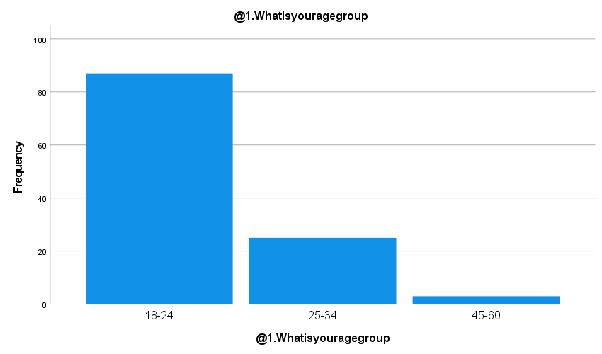

**Figure 1: Frequency @Age group**

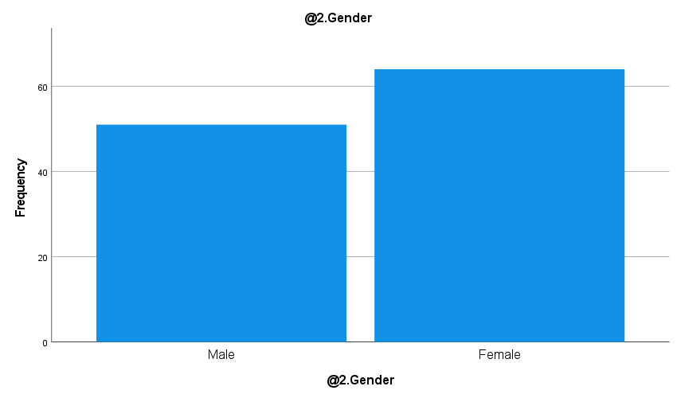

**Figure 2: Frequency @Gender**

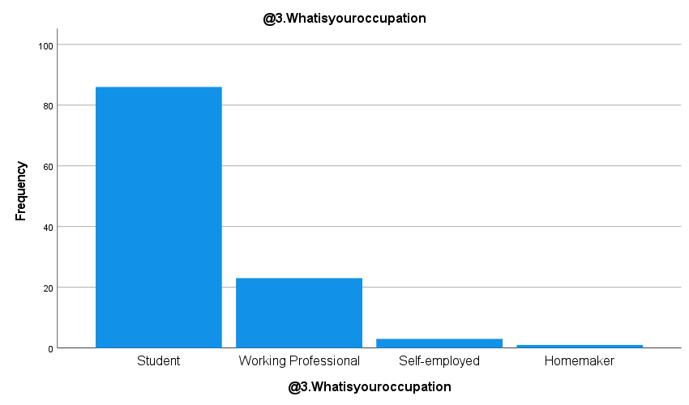

**Figure 3: Frequency @Occupation**

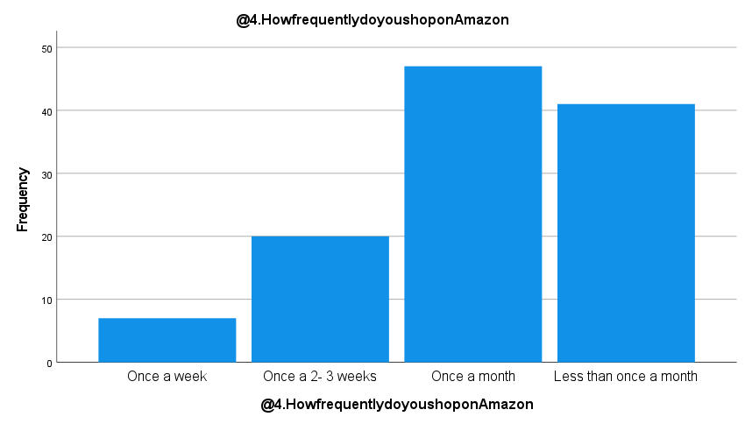

**Figure 4: Frequency @Amazon shopping Frequency**

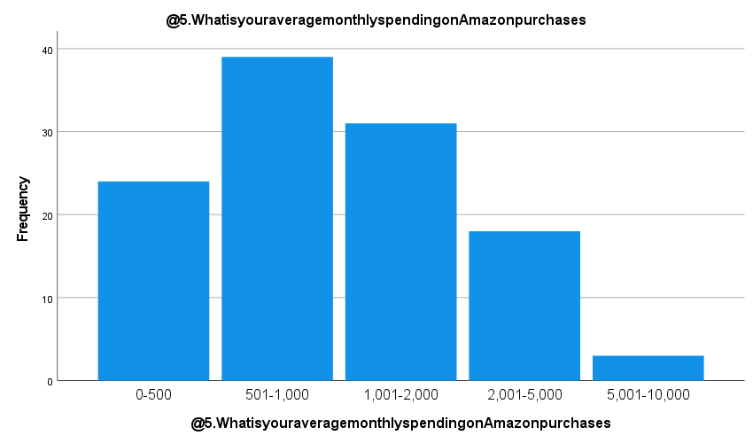

**Figure 5: Frequency @Average amazon purchases**

Gender: The gender distribution shows a nearly even split, with a slightly higher number of female respondents (Mean=1.56). The low standard deviation (0.249) indicates minimal variability in gender representation.

Occupation: The majority of respondents are students, as indicated by the dominant category in responses (Mean=1.28). The low variation (0.312) confirms that most participants belong to a single occupational group.

Shopping Frequency on Amazon: Respondents generally shop frequently on Amazon (Mean=1.30). The moderate standard deviation (0.607) suggests some variation in shopping habits, but overall frequency leans towards the higher side.

Average Monthly Spending on Amazon: Most participants report moderate monthly spending on Amazon purchases (Mean=3.06). However, the high variance (0.777) reflects considerable diversity in spending behaviours among users.

Purchase Based on Number of Reviews: A strong majority of respondents confirmed that they base their purchase decisions on the number of reviews (Mean = 1.11). The very low standard deviation (0.318) indicates highly consistent behaviour across the sample

Product Categories Usually Purchased: There is a wide spread in the types of products purchased, suggesting that respondents buy across various product categories. The high variation reflects diverse consumer interests.

Relying on Reviews for Electronic Items (Search Goods): Most respondents rely heavily on reviews before purchasing electronics. However, the higher variance shows that the extent of reliance varies among individuals.

Relying on Reviews for Clothing Items (Experience Goods): Similar to electronics, respondents tend to depend on reviews for clothing purchases. While the average agreement is high, variability suggests different levels of trust in reviews for experience goods.

Trust in "Amazon’s Choice" Label: The results indicate moderate trust in Amazon’s "Amazon’s Choice" label. The standard deviation reflects a divided opinion among customers regarding the reliability of this label.

Influence of Reviews on Expensive vs. Cheaper Products: Respondents show a stronger reliance on reviews when purchasing expensive products, suggesting that perceived risk plays a significant role in review dependence.

Trust in “Verified Purchase” Tags: Reviews marked with a “Verified Purchase” tag are widely considered more trustworthy. This reflects users' preference for authenticity in feedback.

Perception of Fake or Paid Reviews: A majority believe that some reviews on Amazon may be fake or paid. While this belief is widespread, the moderate variation shows that skepticism differs across users.

Impact of Photos/Videos in Reviews: This statement received the strongest agreement. Users overwhelmingly trust reviews that include visual elements such as photos or videos, indicating the value of visual proof in building trust.

Preference for Detailed Reviews Over Short Ones: Respondents clearly favor detailed reviews over shorter ones, with high consistency across the sample. This suggests that content-rich reviews significantly impact decision-making.

Buying Behavior for Unreviewed/New Products: Most users prefer to wait for others to review newly launched products before purchasing (Mean =3.87). This reflects a cautious approach and a tendency to avoid risk in the absence of prior feedback.

Impact of Positive Reviews: Positive reviews and ratings greatly enhance users' confidence in purchasing a product (Mean =3.67). This highlights the persuasive power of favourable feedback.

Impact of Negative Reviews: Negative reviews have a strong influence on purchasing decisions (Mean = 3.94). Most respondents report that poor ratings can deter them from buying a product.

Preference for Highly Reviewed Products: Products with a high number of reviews are generally preferred (Mean = 3.86). The response pattern shows a strong and consistent behaviour across the user base.

Trust in Quantity of Reviews Over Rating Quality: Respondents are more likely to trust products with a large number of reviews (Mean = 3.89), even if the average rating is not very high. However, this trust is slightly weaker compared to other review-related factors.

I’m more Likely to Trust Products that have a lot of Reviews: Even if the overall rating isn’t very high, respondents tend to trust products with a high volume of reviews (Mean = 3.43), although this trust is slightly lower compared to other review-related factors.

## 4.2 Inferential Analysis

*Hypothesis 1: Perception of product reviews and ratings impact on consumer purchase behaviour across different product categories.*

Frequencies:

**Table 2: Hypothesis 1- Age Group Frequency**

Age Group Interpretation:

* Majority of our respondents (75.7%) are in the 18–24 age group.
* The remaining are age groups are: 25–34 (21.7%) and 45–60 (2.6%).
* This data is a bit tended towards the 18-24 age group so this results signify youth-centered approach, as most young people use amazon and buy according to the reviews and expert opinions.

**Table 3: Hypothesis 1- Purchased Category Frequency**

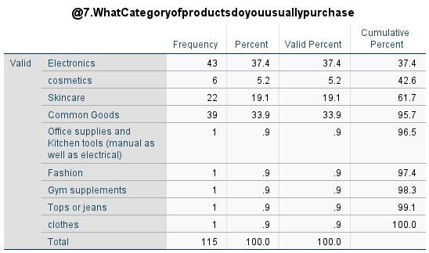

The most frequently purchased categories are:

* Electronics (37.4%)
* Common goods (33.9%)

These categories are generally associated with high involvement and higher informationneeds, which explains why review-based decision-making is prominent.

Products like skincare (19.1%) also rely heavily on experience-based reviews, indicating the importance of qualitative feedback.

Niche categories like fashion, gym supplements, and clothes each have very few respondents (<1%), meaning the findings are less generalizable for those areas.

**Table 4: Hypothesis 1- Gender Frequency**

In the survey, female respondents made up 55.7% of the sample, while male respondents accounted for 44.3%. This shows a slight majority of female participants, which means some of the findings might slightly reflect female consumer behavior more.

Reliability test:

**Table 5: Hypothesis 1- Reliability Test**

The high Cronbach’s Alpha (0.902) indicates that the items have significant internal consistency, and we can confidently use them for further analysis related to consumer behavior and product reviews.

Factor Analysis:

**Table 6: Hypothesis 1- KMO and Bartlett's Test**

|  |  |  |
| --- | --- | --- |
|  | | |
| Kaiser-Meyer-Olkin Measure of Sampling Adequacy. | | .877 |
| Bartlett's Test of Sphericity | Approx. Chi-Square | 738.683 |
| df | 78 |
| Sig. | .000 |

The KMO value of 0.877 shows that the data is highly suitable for factor analysis. Also, since the significance value in Bartlett’s Test is less than 0.001, it confirms that there is a significant relationship between variables, so factor analysis can be confidently applied.

Anova:

**Table 7: Hypothesis 1- ANOVA**

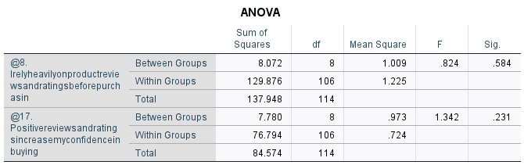

For both items, the Sig. values are greater than 0.05, which means there is no significant difference between groups in how they responded to these two statements. Participants across different groups responded similarly when it comes to relying on reviews before purchasing and gaining confidence from positive reviews.

*Hypothesis 2: Consumers are more likely to trust and purchase products with a higher volume of positive reviews.*

Correlation:

**Table 8: Hypothesis 2- Correlation between @6, @17, @19 and @20**

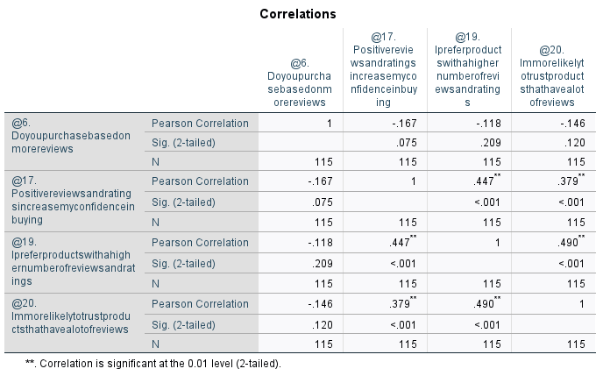

@17 and @19 (r = 0.447, p < 0.001)

* Positive and significant correlation.
* Students who say positive reviews increase their confidence also prefer products with a higher number of reviews and ratings.

@17 and @20 (r = 0.379, p < 0.001)

* Positive and significant.
* If someone gains confidence from positive reviews, they are more likely to trust products with lots of reviews.

@19 and @20 (r = 0.490, p < 0.001)

* Strongest positive and significant correlation.
* People who prefer products with a higher number of reviews are also more likely to trust those products.

Regression:

**Table 9: Hypothesis 2- Regression**

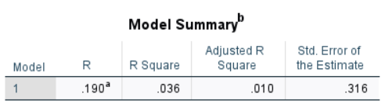

R = 0.190: This is the correlation between the predicted and actual values. A value close to 1 means a strong relationship, so 0.190 is moderately positively correlated.

**Table 10: Hypothesis 2- ANOVA**

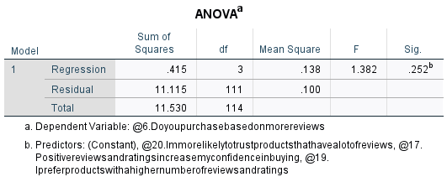

The p-value is 0.252, which is greater than 0.05. This means the regression model is not statistically significant. Also, even the coefficients are not supporting the regression model so these variables are not significantly impacting each other directly. May be some external factors are affecting these variables as Beta values show negative relationship.

Mann Whitney-Test:

**Table 11: Hypothesis 2- Mann-Whitney Test**

Since p < 0.001, the result is statistically significant at the 0.01 level.

There is a significant difference between the two groups. People who prefer products with many reviews (Q19) are significantly more likely to say that positive reviews and ratings increase their buying confidence (Q17).

Chi-Square Test:

**Table 12: Hypothesis 2- Chi-Square Test**

There is a statistically significant association between the variables (Pearson Chi-Square, p = .019).

*Hypothesis 3: Negative reviews have a stronger influence on consumer decision-making compared to positive reviews.*

Paired T-Test:

**Table 13: Hypothesis 3- Paired Sample Correlation**

The positive reviews and negative reviews are positively correlated.

**Table 14: Hypothesis 3- Paired T-Test**

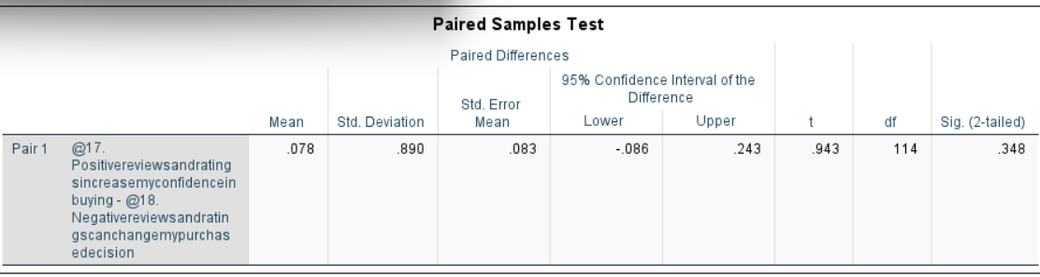

As the p-value is greater than 0.05, we fail to reject the null hypothesis and accept it.

Multiple Regression:

**Table 15: Hypothesis 3- ANOVA**

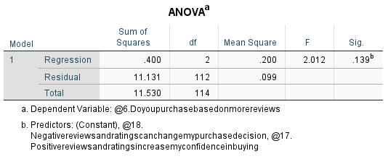

As the significance value is greater than 0.05 we can say that there no influence of positive or negative reviews on dependent variable.

**Table 16: Hypothesis 3- Multiple Regression**

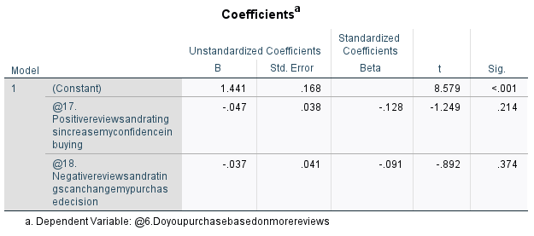

The p value is greater than 0.05 so we reject alternative hypothesis and say there is no impact of reviews and purchasing may be other factors might be affecting the purchasing behaviour.

*Hypothesis 4: The credibility of reviews significantly affects consumer trust and willingness to make a purchase.*

Correlation:

**Table 17: Hypothesis 4- Correlation with @6**

Weak negative correlations with almost all other variables. Which tells us that the people who rely mainly on number of reviews may not care much about quality of reviews (e.g., details or photos).

**Table 18: Hypothesis 4- Correlation with @12**

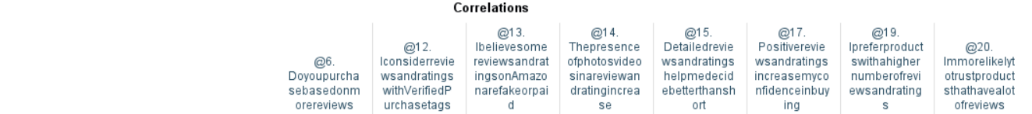



Negatively related to buying based on review count but strongly relayed to other variables. It tells us that these users care more about authenticity and depth than just quantity.

**Table 19: Hypothesis 4- Correlation with @13**





Weak to moderate positive correlations with other beliefs, especially for Verified purchase tags (@12) and Photos/videos (@14). It looks like People who distrust reviews may look for extra proof like verified tags and visuals.

**Table 20: Hypothesis 4- Correlation with @14**





One of the strongest correlating variables. It highly correlates with confidence in buying (@17), trust in many reviews (@20), and detailed reviews (@15). It indicates that visuals strongly boost trust and decision-making.

**Table 21: Hypothesis 4- Correlation with @15**





It strongly positively correlates with Confidence (@17), Preference for more reviews (@19), and Trust in review volume (@20). This suggests that the quality of content (not just star rating) drives decisions.

**Table 22: Hypothesis 4- Correlation with @17**





Highly correlated with most other variables like detailed reviews, verified tags, visuals, trust in high volume, etc. It shows that positive, credible content builds buying confidence.

**Table 23: Hypothesis 4- Correlation with @19**





There is strong positive relationship with detailed reviews, confidence, and photos/videos. Which indicates that people want both quantity and quality to feel secure in buying.

**Table 24: Hypothesis 4- Correlation with @20**





There are strong positive relationships with most beliefs. These users also value verified tags, detailed content and visuals. It suggests that *volume + quality = trust.*

Regression:

**Table 25: Hypothesis 4- Regression**

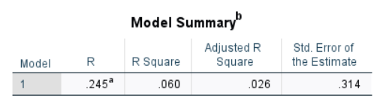

R = 0.245 - Moderate correlation between the predicted and actual values.

R² = 0.060 - There is only 6% of the variation in purchase behavior based on more reviews is explained by these four predictors.

As these don’t strongly support why people by based on more reviews may most of the behavior is influenced by other factors not included here.

**Table 26: Hypothesis 4- ANOVA**

F-value = 1.763, Sig. = .141 Since p > 0.05, the model is not statistically significant. So, the combination of the predictors does not significantly predict buying behavior based on review count.

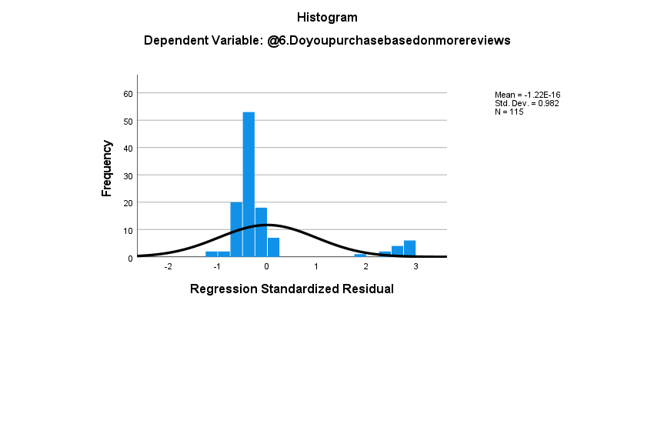

**Figure 6: Hypothesis 4- Histogram for @6**

The histogram shows a roughly normal distribution of errors.

**Figure 7: Hypothesis 4- P-P Plot of Regression for @6**

P-P Plot is mostly aligned to the line, which indicates that normality assumption is met. The assumptions are met but it doesn’t explain anything else in detail.

Overall, the above regression model tried to see if trust in detailed reviews, photos/videos, verified tags, or skepticism about fake reviews predicts whether someone buys based on review count. But the model was not statistically significant, and none of the factors had a strong individual effect. So, people’s tendency to buy based on review numbers alone might be driven by other things like urgency, popularity, or just habit.

# Chapter 5: Findings, Discussion, and Implications

## 5.1 Discussion on Major Findings

* The study sample was dominated by young adults aged 18–24 (75.7%), indicating a youth-centric pattern in online shopping behavior. This demographic relies heavily on digital cues such as reviews, ratings, and social proof when making purchasing decisions. Their digital fluency and familiarity with online platforms like Amazon explain their dependence on reviews and visual content.
* Electronics (37.4%) and common goods (33.9%) were the most purchased product categories. These are typically high-involvement products, where consumers require extensive information before making a decision. Review reliance in these categories was particularly strong, with consumers prioritizing review volume, verified purchase tags, and photos/videos to reduce perceived risk.
* Skincare (19.1%), classified as an “experience good,” also showed high review reliance, especially for qualitative and emotional feedback. However, product categories like fashion and gym supplements had very low response rates, suggesting that results for niche categories are not as generalizable.
* Positive reviews significantly enhance consumer confidence and purchase intent, as shown in correlations between variables @17 (confidence) and @19 (preference for more reviews), and between @17 and @20 (trust in review volume). The strongest correlation was between preferring more reviews and trusting them (r = 0.490). However, regression analysis showed that while there is a moderate relationship (R = 0.190), the overall model was not statistically significant (p = 0.252). This suggests that while people express confidence in review volume, other external factors—like urgency, brand, or promotional campaigns—may influence their actual purchase decision.
* Consumers placed high trust in reviews with: verified purchase tags, photos/videos (strongest trust indicator) and detailed written feedback. These factors emerged as critical credibility indicators. Correlation analysis revealed that trust in these elements also strongly aligned with purchasing confidence. This supports Trust Formation Models in e-commerce, where authenticity and detail foster greater buying intent.
* Consumers showed moderate trust in Amazon’s “Amazon’s Choice” label. The variation indicates skepticism, possibly due to concerns about algorithmic bias or the lack of transparency in how the label is awarded.
* While most respondents stated that negative reviews influenced their decision-making (Mean = 3.94), the paired t-test and regression analysis showed no statistically significant predictive power. This implies a perception-reality gap—consumers believe they’re deterred by negative feedback, but in practice, other variables may override this (e.g., price, brand loyalty, need urgency).
* The study found that consumers tend to avoid purchasing newly launched or unreviewed products, preferring to wait for early adopters to post feedback. This suggests a herding behavior, where consumers rely on the collective opinion before making risky purchases.
* Respondents showed a strong inclination toward trusting products with a higher number of reviews, even if the overall rating was average. However, weak correlations between this variable and actual trust highlight a nuanced insight: volume alone isn’t enough—quality indicators must accompany it.
* A significant number of respondents believed some reviews on Amazon were fake or paid. However, instead of abandoning reviews altogether, consumers compensate by seeking out additional proof, such as user-uploaded images or verified purchase status. This aligns with Information Diagnosticity Theory, where detailed and seemingly objective content is perceived as more useful and credible.
* Across all hypotheses tested via regression, models showed low R² values (e.g., 6% for purchase behavior based on review count). This means that while reviews and ratings are important, they alone do not fully explain purchase decisions. Other variables—emotional needs, delivery times, brand equity, or price discounts—likely play major roles.

## 5.2 Practical Implications

*For Businesses:*

* Since review volume boosts consumer confidence, incentivizing review submissions (especially after verified purchases) can enhance trust and increase conversions.
* Platforms should invest in AI and moderation tools to identify and suppress fake reviews, maintaining long-term consumer trust.

*For Managers:*

* Managers should actively manage online reputation. Encouraging satisfied customers to post detailed, honest reviews; especially with visuals can influence buying decisions more than traditional ads.
* For high-involvement products, it’s essential to provide extensive information, tutorials, and visual demos to complement user reviews.

*For Consumers:*

* While relying on review volume is common, consumers should prioritize the credibility of individual reviews (detailed, verified, with visuals) over sheer quantity.
* Consumers should remain cautious of potential fake reviews and use multiple cues (e.g., verified tags, balanced opinions) to evaluate authenticity.

# Chapter 6: Conclusion and Recommendations

## 6.1 Summary of the study

This study explored how product reviews and ratings on Amazon impact consumer purchase behavior, especially across different product categories and age groups. With a sample of 115 respondents, primarily aged 18–24, the study applied quantitative methods like correlation, regression, and inferential statistical testing. Key findings show that while review volume significantly boosts trust and purchase confidence, the quality of reviews (verified, detailed, with visuals) plays a critical role in influencing decisions. Although positive and negative reviews affect consumer perceptions, regression results suggested that many external factors also shape buying behavior. The research highlights the complex interplay between review content, credibility, and consumer psychology in the digital shopping environment.

## 6.3 Limitations of the study

* The sample size (115 respondents) limits generalizability, particularly for underrepresented product categories like fashion and gym supplements.
* The study leaned heavily toward a younger demographic (75.7% aged 18–24), which may not reflect older consumer behavior accurately.
* Regression models had low explanatory power, suggesting omitted variables like brand loyalty or delivery experience might also impact decisions.
* The self-reported nature of surveys may introduce response bias.

## 6.4 Suggestions for future research

* Future studies should aim for a more diverse and larger sample across different age groups and professions to enhance generalizability.
* Including qualitative interviews or focus groups could deepen understanding of the psychological drivers behind reliance on reviews.
* Researchers could explore the role of emerging technologies like AI-generated reviews or recommendation systems in shaping consumer trust.
* Comparative studies between platforms (e.g., Amazon vs. Flipkart) may uncover platform-specific consumer behavior differences.

To conclude, this study offers a bird’s eye view of the topic due to time constraint, yet it yields few valuable insights which contribute to the existing literature and guide future research in this area.

# References

* Ahn, Y. and Lee, J. (2024). The Impact of Online Reviews on Consumers’ Purchase Intentions: Examining the Social Influence of Online Reviews, Group Similarity, and Self-Construal. Journal of Theoretical and Applied Electronic Commerce Research, 19, pp.1060–1078. <https://www.researchgate.net/publication/380508657_The_Impact_of_Online_Reviews_on_Consumers'_Purchase_Intentions_Examining_the_Social_Influence_of_Online_Reviews_Group_Similarity_and_Self-Construal>
* Bo, L., Chen, Y. & Yang, X. (2023) ‘The Impact of Contradictory Online Reviews on Consumer Online Purchase Decision: Experimental Evidence from China’, SAGE Open, April–June, pp. 1–18. <https://doi.org/10.1177/21582440231180107>
* Chen, T., Samaranayake, P., Cen, X., Qi, M. & Lan, Y.C. (2022) ‘The Impact of Online Reviews on Consumers’ Purchasing Decisions: Evidence From an Eye-Tracking Study’, Frontiers in Psychology, 13, p. 865702. <https://doi.org/10.3389/fpsyg.2022.865702>
* Consumer Behavior Report. (2021). Understanding Online Shopping Trends and Consumer Trust. <https://www.google.com/url?sa=t&source=web&rct=j&opi=89978449&url=https://s3.amazonaws.com/media.mediapost.com/uploads/2021_Consumer_Behavior_Report.pdf&ved=2ahUKEwiM_MzvspWNAxWsmK8BHZCGLogQFnoECBgQAQ&usg=AOvVaw1mg58elSJ43hNLgxtWi1HH>
* Gupta, M. (2021). The Impact of Mobile Shopping Apps on Consumer Purchase Decisions in India. <https://ijsret.com/wp-content/uploads/2023/03/IJSRET_V9_issue2_189.pdf>
* Helmi, S. et al. (2024). The Impact of Online Reviews and Volume Reviews on Consumer Purchase Decisions in Shopee: A Quantitative Analysis. MORFAI Journal, 4(3). <https://www.researchgate.net/publication/387521837_THE_IMPACT_OF_ONLINE_REVIEWS_AND_VOLUME_REVIEWS_ON_CONSUMER_PURCHASE_DECISIONS_IN_SHOPEE_A_QUANTITATIVE_ANALYSIS>
* Kang, M., Sun, B., Liang, T. and Mao, H.-Y. (2022). A study on the influence of online reviews of new products on consumers’ purchase decisions: An empirical study on JD.com. Frontiers in Psychology, 13, 983060. <https://doi.org/10.3389/fpsyg.2022.983060>
* Khan, H. (2021). Examining the Buying Behavior of Online Consumers in India During the Pandemic COVID-19. <https://www.researchgate.net/publication/355043563_Examining_the_Buying_Behavior_of_Online_Consumers_in_India_During_the_Pandemic_COVID-19>
* Mallik, S. K., Uddin, I., Akter, F., Rahman, A. S. M. S., and Abeedur Rahman, M (2025). Evaluating the influence of customer reviews and consumer trust on online purchase behavior. World Journal of Advanced Research and Reviews, 25(01), pp. 423-432. <http://dx.doi.org/10.30574/wjarr.2025.25.1.0015>
* Mishra, A., Salih, M., Topno, P. and Shashank. (2024). The Impact of Customer Reviews and Ratings on Brand Reputation and Sales. JETIR, 11(5). <https://www.jetir.org/papers/JETIR2405331.pdf>
* Mudambi, S.M. & Schuff, D. (2010) ‘What Makes a Helpful Online Review? A Study of Customer Reviews on Amazon.com’, MIS Quarterly, 34(1), pp. 185–200. <http://dx.doi.org/10.2307/20721420>
* Nandagopal, R., Manokaran, G. and Jayakumar, A. (2024). Impact of Online Reviews on Consumer Purchasing Decisions. AIMS International Conference. <https://aims-international.org/aims22/22AProceedings/PDF/A518-Done.pdf>
* Pooja, K. & Upadhyaya, P. (2024) ‘What Makes an Online Review Credible? A Systematic Review of the Literature and Future Research Directions’, Management Review Quarterly, 74(3), pp. 627–659. <http://dx.doi.org/10.1007/s11301-022-00312-6>
* Randa, A. (2024). From Browsing to Buying: How Reviews Influence Consumer Behavior. Brand Testing Club. <https://business.brandtestingclub.com/blog/from-browsing-to-buying-how-reviews-influence-consumer-behavior>
* Rathva, M., & Rajput, A. (2024). A Comprehensive Study on Consumer Buying Behavior on Amazon Online Shopping in India. International Research Journal of Modernization in Engineering Technology and Science, 6(3), 3925-3928. <https://www.irjmets.com/uploadedfiles/paper//issue_3_march_2024/51112/final/fin_irjmets1711370588.pdf>
* Rawat, K. (2023) ‘The Influence of Reviews and Ratings on Consumer Purchase Decision’, Man-Made Textiles in India, July, pp. 223–225. <https://www.researchgate.net/publication/372862142_The_influence_of_reviews_and_ratings_on_consumer_purchase_decision>
* Sandhe, A. (2019). The Effect of Consumer Attitude on Purchasing Intention for Organic Products. <https://doi.org/10.29121/granthaalayah.v7.i2.2019.987>
* Sani, S.N.M. (2024) ‘A Study on Impact of Online Reviews and Ratings Influence on Consumer Trust and Purchasing Decisions in the Digital Marketplace’, International Journal of Science and Research, 13(11). <http://dx.doi.org/10.21275/SR241120192601>
* Sankhla, S., Katiyar, A. and Gupta, V. (2024). The Influence of Online Reviews on Consumer Learning and Purchase Decisions. IRJAEM, 2(11), pp.3427–3430. <https://doi.org/10.47392/IRJAEM.2024.0504>
* Sharma, R. (2014). Impact of Digital Marketing on Consumer Buying Behavior in India. <https://doi.org/10.1007/978-3-030-24374-6_5>
* Sharma, R. K. (2015). E-commerce in India: Factors Influencing Online Shopping Behavior. <http://dx.doi.org/10.13165/ST-15-5-1-06>
* Siddiqui, K. and Bisaria, C. (2025). Influence of Reviews and Ratings on Consumer Online Purchase Decision. IJCRT, 13(3). <https://www.ijcrt.org/papers/IJCRT2503712.pdf>
* Simanjuntak, S.M., Luthfiyyah, S.P., Wulanda, A. and Situmorang, S.H. (2024). The Impact of Online Reviews and Volume Reviews on Consumer Purchase Decisions in Shopee: A Quantitative Analysis. MORFAI Journal. <http://dx.doi.org/10.54443/morfai.v4i3.2190>
* Sung, E., Chung, W.Y. & Lee, D. (2023) ‘Factors that Affect Consumer Trust in Product Quality: A Focus on Online Reviews and Shopping Platforms’, Humanities and Social Sciences Communications, 10(766). <http://dx.doi.org/10.1057/s41599-023-02277-7>
* Zhang, J., Zheng, W. and Wang, S. (2020). The Study of the Effect of Online Review on Purchase Behavior. International Journal of Crowd Science, 4(1), pp.73–86. <http://dx.doi.org/10.1108/IJCS-10-2019-0027>

# Annexures

*Copy of Final Questionnaire*

**Questionnaire: A Purchase Behaviour Analysis with Product Reviews and Ratings on Amazon Customers**

**Section A: Demographics**

1. What is your age group?

• 18–24

• 25–34

• 35–44

• 45 and above

1. Gender:

• Male

• Female

• Prefer not to say

1. What is your occupation?

• Student

• Working Professional

• Self-employed

• Homemaker

• Other

1. How frequently do you shop on Amazon?

• Once a week

• Once in 2–3 weeks

• Once a month

• Less than once a month

1. What is your average monthly spending on Amazon purchases?

* Less than ₹500
* ₹500 - ₹1,000
* ₹1,000 - ₹2,000
* ₹2,000 - ₹5,000
* More than ₹5,000

**Section B: Purchase Behaviour Based on Reviews and Ratings**

*Product Categories & Influence*

1. Do you purchase based on more reviews

* Yes
* No

1. What category of products do you usually purchase?

* Electronics
* Cosmetics
* Skincare
* Common Goods
* Other:

1. I rely heavily on product reviews and ratings before purchasing electronic items (search goods) on Amazon.

*Strongly Disagree | Disagree | Neutral | Agree | Strongly Agree*

9. I rely heavily on product reviews and ratings before purchasing clothing items (experience goods) on Amazon.

*Strongly Disagree | Disagree | Neutral | Agree | Strongly Agree*

10. I trust Amazon’s “Amazon’s Choice” label while making decisions.

*Strongly Disagree | Disagree | Neutral | Agree | Strongly Agree*

11. I am more influenced by reviews and ratings for expensive products than for cheaper ones.

*Strongly Disagree | Disagree | Neutral | Agree | Strongly Agree*

*Review and Rating* *Credibility*

12. I consider reviews and ratings with “Verified Purchase” tags to be more trustworthy.

*Strongly Disagree | Disagree | Neutral | Agree | Strongly Agree*

13. I believe some reviews and ratings on Amazon are fake or paid.

*Strongly Disagree | Disagree | Neutral | Agree | Strongly Agree*

14. The presence of photos/videos in a review and rating increases my trust in the product.

*Strongly Disagree | Disagree | Neutral | Agree | Strongly Agree*

15. Detailed reviews and ratings help me decide better than short ones.

*Strongly Disagree | Disagree | Neutral | Agree | Strongly Agree*

*16. If a product has no reviews or ratings (e.g., newly launched or newly available on Amazon), I would prefer to wait for others to review it before purchasing.*

*Strongly Disagree | Disagree | Neutral | Agree | Strongly Agree*

*Review and Rating Valence (Positive vs Negative)*

17. Positive reviews and ratings increase my confidence in buying a product.

*Strongly Disagree | Disagree | Neutral | Agree | Strongly Agree*

18. Negative reviews and ratings can change my purchase decision.

*Strongly Disagree | Disagree | Neutral | Agree | Strongly Agree*

*Review Volume*

19. I prefer products with a higher number of reviews and ratings.

*Strongly Disagree | Disagree | Neutral | Agree | Strongly Agree*

20. I’m more likely to trust products that have a lot of reviews, even if the overall rating isn’t very high.

*Strongly Disagree | Disagree | Neutral | Agree | Strongly Agree*